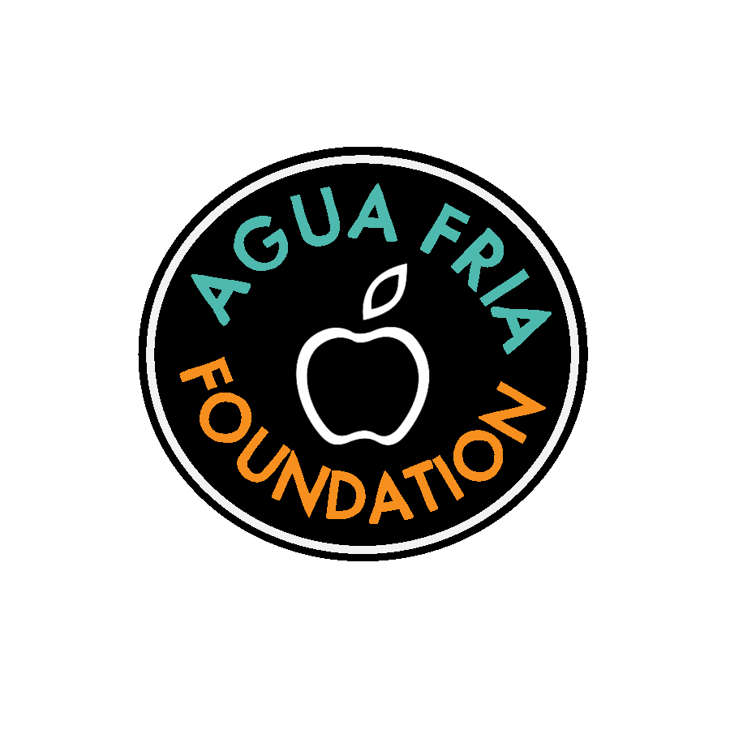
The Dennis Runyan Innovation Grant via the Agua Fria Foundation 2022-2023
In honor of his years of service and great collaboration with the Agua Fria Foundation, we would like to announce a $5,000 grant in Dr. Runyan's name. This grant will be given to a cross-curricular team of teachers who apply to the Foundation with a wide-reaching project that is innovative and gives students an extraordinary opportunity to learn beyond the boundaries of the traditional classroom.

Our Mission: The Agua Fria Fondation invites all interested district teachers to apply to the foundation for the first cross-curricular Runyan Innovation Grant between July 2022 and October 2022. This $5000 grant will be distributed at the start of the 2nd semester of the 2022-2023 school year. These projects and programs must be outside of the standard curriculum and demonstrate the potential to positively impact student learning and must be consistent with District goals.

Eligible Applicants: Full Time teaching faculty may apply during the application period. The winning project(s) must feature cross-curricular planning by at least two teachers from different departments. The goal is to increase inter-department planning and communications for curriculum development and student learning outcomes.

Grant requests considered by Dr. Runyan and the Agua Fria Foundation should not exceed $5,000. Total amount requested must include shipping and tax costs. Typically, the foundation will fund one grant request per project and a teacher/teachers may only be awarded once per school year.

Grant Applicants Checklist:
- Complete Grant Application and Cover Sheet
- Print Grant Application and Cover Sheet
- Attach documentation of requests and denials (copies of emails are sufficient)
- Attach budget information/quotes
- Get required signatures (Campus technician if applicable, Principal on Cover Sheet required)
- Submit grant application to site representative at least one month prior to the next meeting

Site Representatives:
- Agua Fria- Celina German
- Canyon View- TBD (Contact Jcole@aguafria.org)
- Desert Edge -Jennifer Cole
- Millennium- Josh Dockall
- Verrado - Kelli Orth

Before completing the Grant application, please ensure no other funding is available through your school, district, or federal programs. Please provide documentation of requests and denials from the appropriate school / department / federal program (principal, CTE, ESS, SEI, etc.)

Review Process: All applications are reviewed by a site representative, the Grants Committee chairperson, and the Director of Educational Services. All requests for funding are then submitted to the Foundation board for careful consideration. The grant applicant will be notified when the proposal will be reviewed by Dr. Runyan and the Foundation and will be invited to make a brief presentation to the board about the project for which they are seeking funding.

Award Announcement: The grant applicant will be notified within one week following the board meeting.

Once grant is funded:
- Applicants check with administrative assistants 2 weeks after notification of award to place grant orders.
- All unexpended funds will be returned to the Foundation at the end of the fiscal year (June 30). Extensions to the completion date may be granted due to delays and other factors beyond the control of the project manager.
- After grants have been implemented, please share photos of the money in action! We want to see the work that you and kids are doing. Send photos (try to avoid student faces) to jcole@aguafria.org.

****Cover Sheet- please print this page and get the necessary signatures. Once you have the signatures, please scan and submit with the completed application.
Application Date:
Project Title:
Amount Requested: Length of Project:
Start Date: End Date:
Number of Students impacted: Grade Level(s):
Number of Teachers:
Project Coordinator(s):
School Site(s):
The project coordinator should be the individual with primary responsibility for executing the project.

***** If requesting technology, please obtain the campus technicians signature verifying the infrastructure is in place to support the technology.

___________________________________________________ ___________________
Campus Technician Date

Principal’s Name:
There is no site funding available for this project, thus I support this application’s submission to the Agua Fria Foundation.
Principal’s Signature: __________________________________________________________

*Is this project eligible for funding from another department (ex. CTE, ESS, SEI, etc.)? Please attach documentation that you have requested funding from these sources and did not receive sufficient funding.

Check one:
My class is not CTE, SEI, ESS, etc. _______
My class is CTE, SEI, ESS, etc. but this project is not eligible for funding through those departments. _______

For Foundation use only:

Date Received: __________ Curriculum Director:__________
Grants committee review:__________ Submitted to board:__________

Project start date: _________ Project end date: _________ Funds closeout: __________

Project title:
Site(s):
AFF Site Rep’e email address:
Agua Fria - TBD (contact Jennifer Cole, jcole@aguafria.org )
Canyon View- Cami Gardin- cgardin@aguafria.org
Desert Edge - Jennifer Cole- jcole@aguafria.org
Millennium - Josh Dockall- jdockall@aguafria.org
Verrado - Kelli Orth- korth@aguafria.org

Staff Position:
Content / Department:
Grade level(s):
Number of students:
Schools participating:
What educational or curricular objectives/state standards will your project address?

Explain how your project aligns with the District’s goals (PBL, STEM, College & Career Ready, etc.).

Provide a brief summary of your project. Include grade level, number of students and schools involved.

In what ways will your project have a significant impact on students? How will your project be evaluated? What will be the outcomes of your project?

How much money are you requesting from the Foundation? Cannot exceed $5,000 total.

Has your project been previously funded? If so, what year and what was the amount of the grant awarded.

If you have received funds previously for this project, clearly describe the reasons why your project should be considered for additional funding. (For renewal grants to be competitive, other revenue resources are expected to assist with the project costs.)

What co-funding will support this project? For example, what other Agua Fria Union High School District monies, or tax credit funds are part of your project? What community resources have committed project in-kind donations, money or volunteers to the project?

Project Budget Information

Please check one of the following:
- Is the amount requested from the authorized district purchasing source (i.e. authorized vendor or contracted pricing)?

- Is this quote from a sole source? If so, please attach a sole source letter. If neither applies, please provide 3 bids. If approved, the Agua Fria Foundation will fund the lowest quote.

EXPENSES
Grant Other Funds
Supplies, materials, and/or equipment:
Please attach supplemental sheets with descriptions
and costs of each item to be purchased.
Rental of equipment:
Please attach supplemental sheets with descriptions
and costs of each item to be rented.
Resources personnel, professional service:
Please attach supplemental sheets with descriptions and costs
or resources, personnel and professional services being obtained.
Transportation:
Other (Space rental, marketing, trip expenses, etc.:
Please attach supplemental sheets with descriptions
and costs for all expenses included under this line item.
Shipping and Tax: Please include any shipping costs and add 10% for potential taxes.
TOTAL Grant fund requested: ____________________
Total other funds: ____________________
Project Total: ____________________

